OC n° XX
Title should be as brief and as concise as possible. E.g. Synthesis AND CHARACTERIZATION of PEPTIDE LIGANDS
Marcus Tullius Cicero,^{a,*} Caius,^{b}
ª Institute of Chemistry, University of New Orleans, ZIP New Orleans, Louisiana, USA; ^{b} Institute of Chemistry, affiliation of second author
* e-mail: of the corresponding author

lorem ipsum, quia dolor sit, amet, consectetur, adipisci velit, sed quia non numquam eius modi tempora incidunt, ut labore et dolore magnam aliquam quaerat voluptatem. Ut enim ad minima veniam, quis nostrum exercitationem ullam corporis suscipit laboriosam, nisi ut aliquid ex ea commodi consequatur? Quis autem vel eum iure reprehenderit, qui in ea voluptate velit esse, quam nihil molestiae consequatur, vel illum, qui dolorem eum fugiat, quo voluptas nulla pariatur [1]?
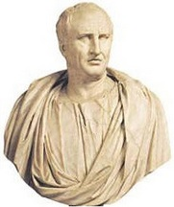
Figure 1

Please name the file like firstname_surname.doc (e.g. OTTO_SCHMIDT.doc).

____
[1] M. T. Cicero, De finibus bonorum et malorum. 45 a.c., Vol, page

